**ABSOLUTEPATH & RELATIVEPATH**

**CODE:**

**package** july;

**import** org.testng.annotations.Test;

**import** org.openqa.selenium.By;

**import** org.openqa.selenium.WebDriver;

**import** org.openqa.selenium.WebElement;

**import** org.openqa.selenium.chrome.ChromeDriver;

**public** **class** Yahoo {

WebDriver driver;

@Test

**public** **void** login1()

{

WebDriver driver;

System.*setProperty*("webdriver.chrome.driver","C:\\ProgramFiles\\Java\\jdk1.8.0_131\\chromedriver.exe");

driver = **new** ChromeDriver();

driver.get("http://yahoo.com") ;

**//Relative path**

WebElement element=driver.findElement (By.*xpath*(".//*[@id='uh-search-box']"));

element.sendKeys("tiliconveli");

**//click search button**

driver.findElement(By.*xpath*(".//*[@id='uh-search-button']")).click();

**//Absolute path**

WebDriver driver1; System.*setProperty*("webdriver.chrome.driver","C:\\ProgramFiles\\Java\\jdk1.8.0_131\\chromedriver.exe");

driver1 = **new** ChromeDriver();

driver1.get("http://techfetch.com") ;

WebElement element1=driver1.findElement (By.*xpath*("html/body/form/div[43]/div/ul/div/div/div[3]/div/div/div[1]/input"));

element1.sendKeys("java");

WebElement element2=driver1.findElement (By.*xpath*("html/body/form/div[43]/div/ul/div/div/div[3]/div/div/div[2]/input"));

element2.sendKeys("Newyork");

**//click fetchjobs button**

driver1.findElement(By.*xpath*("html/body/form/div[43]/div/ul/div/div/div[3]/div/div/div[3]/button")).click();

}

}

**OUTPUT:**

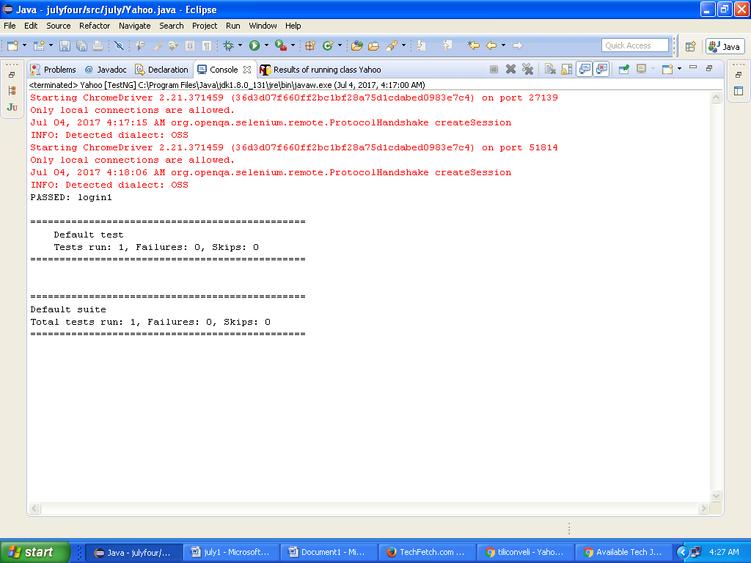

1. **RELATIVEPATH SCREENSHOT:**

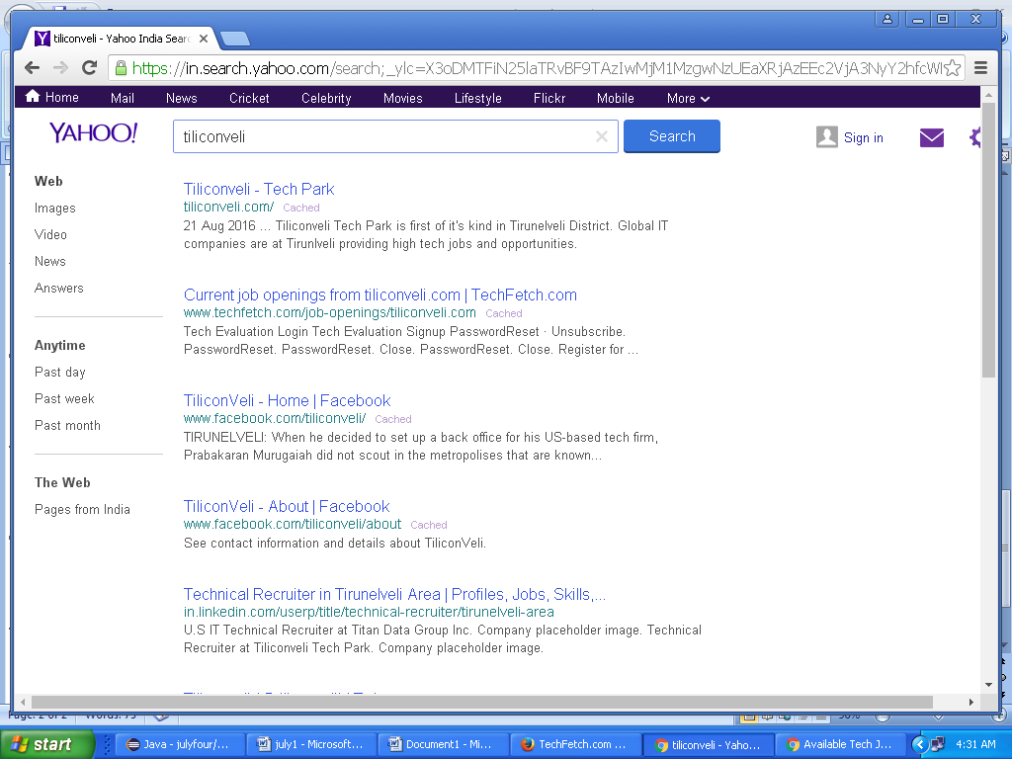

1. **ABSOLUTEPATH SCREENSHOT:**

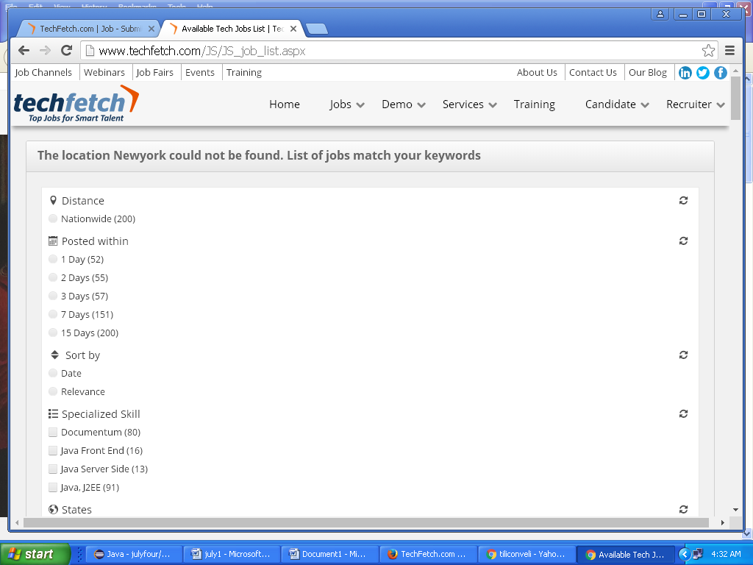

**TEST OUTPUT:**

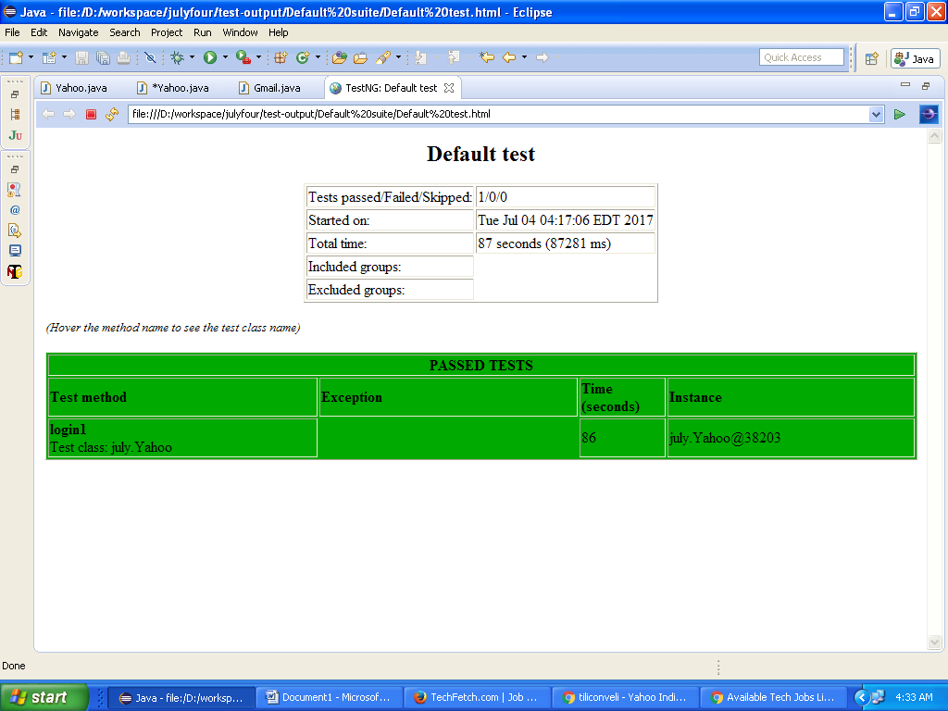

**ALERT PROGRAM**

**CODE:**

**package** alert1;

**import** java.util.concurrent.TimeUnit;

**import** org.openqa.selenium.Alert;

**import** org.openqa.selenium.By;

**import** org.openqa.selenium.WebDriver;

**import** org.openqa.selenium.chrome.ChromeDriver;

**public** **class** A1 {

**public** **static** **void** main(String[] args) **throws** InterruptedException {

WebDriver driver ;

System.*setProperty*("webdriver.chrome.driver","C:\\Program Files\\Java\\jdk1.8.0_131\\chromedriver.exe");

driver= **new** ChromeDriver();

driver.manage().window().maximize();

driver.manage().timeouts().implicitlyWait(5, TimeUnit.***SECONDS***);

driver.get("http://demo.guru99.com/V4/");

driver.findElement(By.*xpath*("html/body/form/table/tbody/tr[1]/td[2]/input")).sendKeys("mngr86125");

driver.findElement(By.*xpath*("html/body/form/table/tbody/tr[2]/td[2]/input")).sendKeys("AnUbUtA");

driver.findElement(By.*xpath*("html/body/form/table/tbody/tr[3]/td[2]/input[1]")).click();

driver.findElement(By.*xpath*("html/body/div[2]/div/ul/li[4]/a")).click();

driver.findElement(By.*xpath*("html/body/table/tbody/tr/td/table/tbody/tr[2]/td[2]/input")).sendKeys("98333");

driver.findElement(By.*xpath*("html/body/table/tbody/tr/td/table/tbody/tr[7]/td[2]/input[1]")).click();

Alert A3 = driver.switchTo().alert();

Thread.*sleep*(2000);

A3.accept();

Or

A3.dismiss();

}

}

**OUTPUT:**

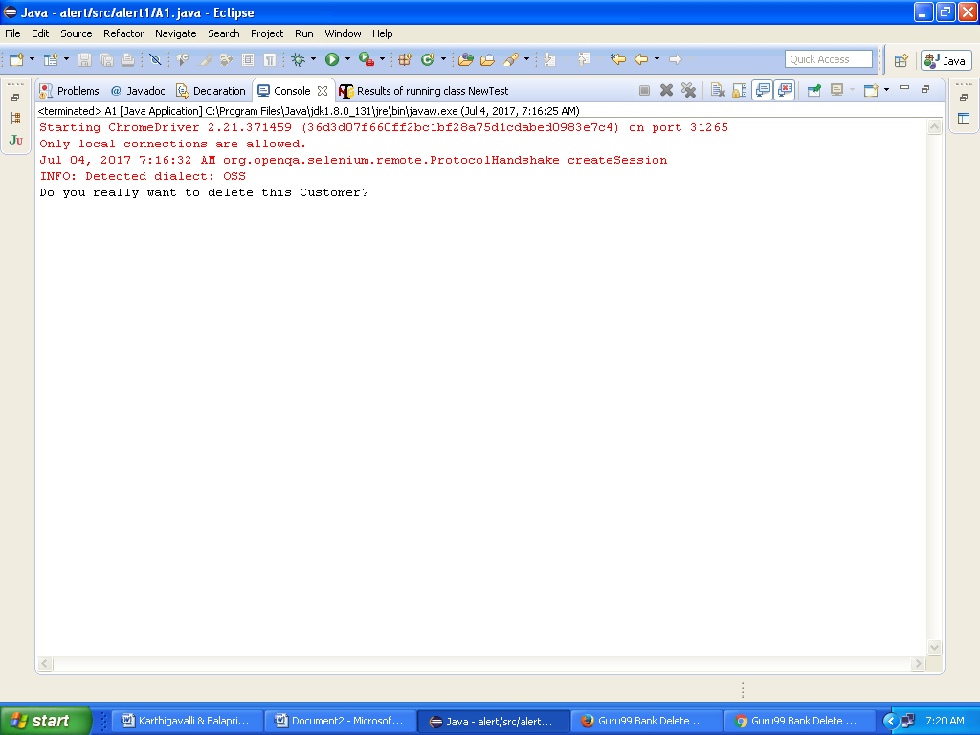

**SCREENSHOT:**

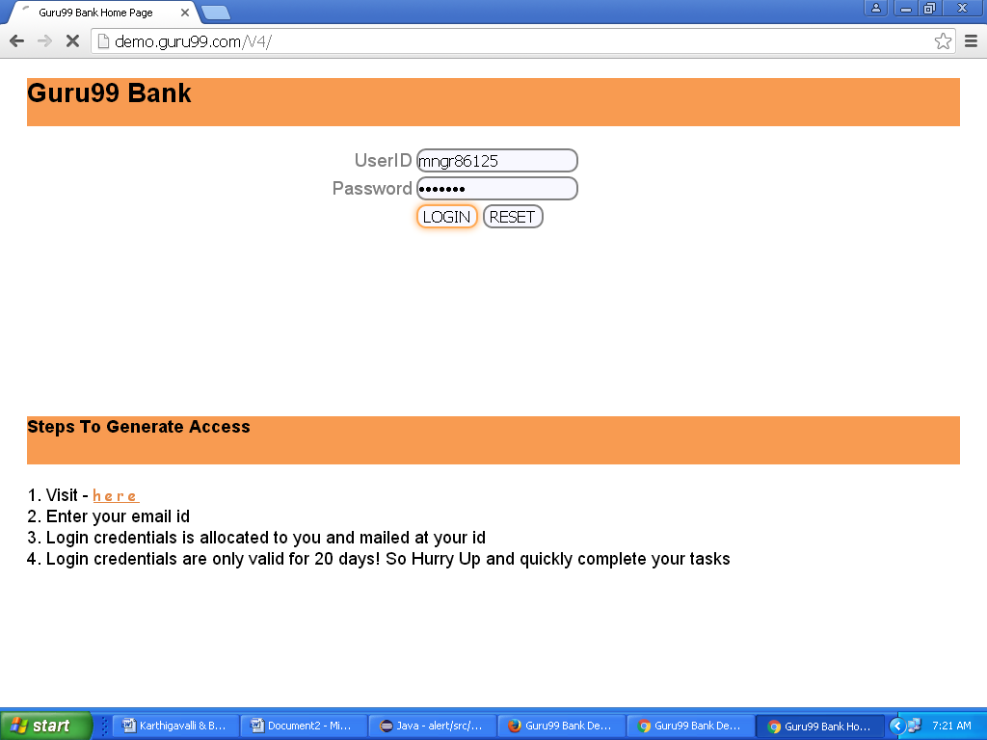

**Accept Screenshot:**

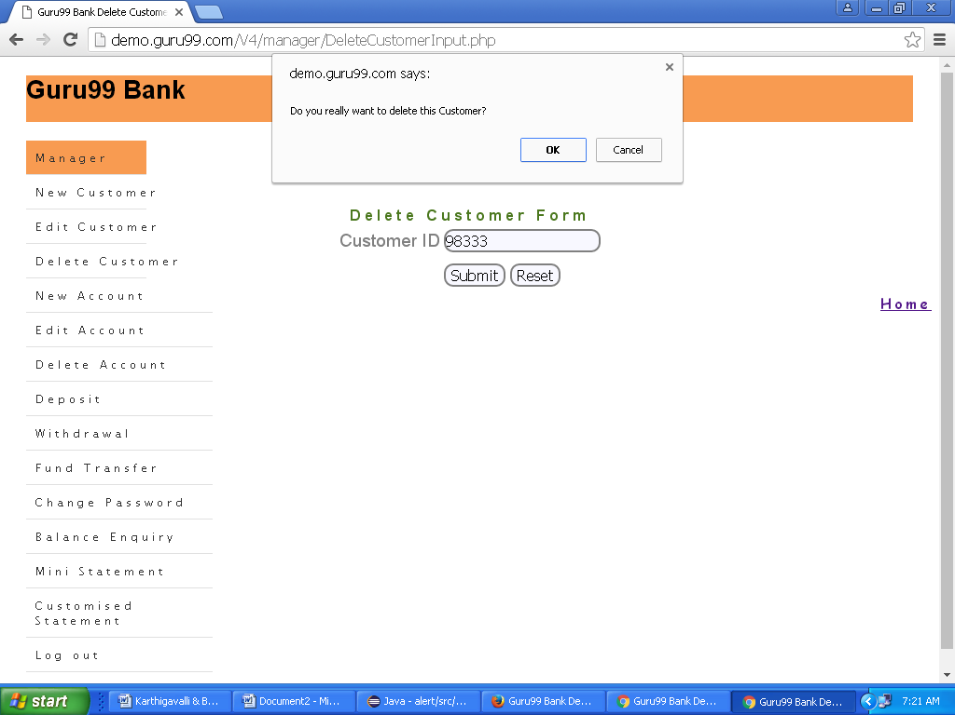

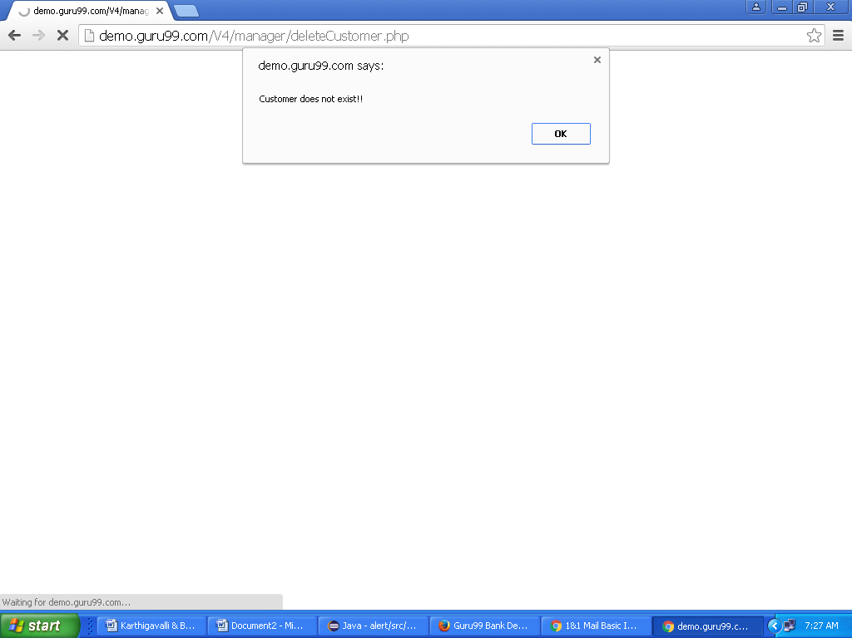

**Dismiss Screenshot:**



